**BLOOD BANK MANAGEMENT SYSTEM**Project submitted to the  
SRM University – AP, Andhra Pradesh

for the partial fulfilment of the requirements to award the degree of  
**Bachelor of Technology**in  
**Computer Science and Engineering  
(Software Engineering)**Submitted by **Y.Narasimha Rao (AP2110010190)**

**  
SRM University–AP  
Neerukonda, Mangalagiri, Guntur  
Andhra Pradesh – 522 240  
[May, 2024]**

**Table of contents:**

1. Abstract.

2. Introduction.

3. Existing System/Literature review.

4. System Requirements.

5. Proposed System.

6. Results/Screenshots

7. Conclusion.

8. References.

# Abstract

The Blood Bank Management System (BBMS) is a Software Engineering project designed to modernize and optimize the operations of blood banks. This system offers a comprehensive and efficient solution for managing all aspects of blood bank operations, including donor management, patient records, blood inventory tracking, and distribution processes.BBMS aims to revolutionize blood bank operations by transitioning from paper-based record-keeping to a digital platform. In the realm of healthcare, efficient management of blood banks stands as a critical necessity for ensuring prompt access to life-saving resources. This project endeavors to address the inherent challenges of traditional manual processes in blood bank management through the development of a web-based solution termed Blood Bank Manager (BBM).

By leveraging technology, BBMS aims to streamline workflows, improve accuracy, and enhance overall efficiency within blood bank facilities. Key features include real-time inventory management and secure access control. BBMS represents a significant advancement in blood bank management, offering a scalable and cost-effective platform to meet the growing demands of healthcare institutions and ensure the availability of life-saving blood products.Ultimately, our goal with the Blood Bank Management System (BBMS) is to significantly improve the efficiency, accuracy, and security of blood bank operations.

# Introduction

A blood bank management system is a software application designed to manage the operations of a blood bank, including the collection, processing, storage, and distribution of blood and blood products. The system provides a user-friendly interface for blood bank staff to manage donor and patient information, track blood inventory.

This project is essential for efficient and effective management of blood banks, as it helps to prevent blood shortages and ensure the safe and timely delivery of blood products to those in need. The implementation of a blood bank management system can significantly improve the overall efficiency and effectiveness of a blood bank, helping to save lives and improve public health outcomes. With the increasing demand for blood and blood products around the world, such systems have become an essential component of modern healthcare infrastructure.

A blood bank management system can help blood banks operate more efficiently, ensure patient safety,increase donor retention, and improve the overall quality of blood products available to patients in need.The main purpose of a blood bank management system is to prevent blood shortages and ensure the safe and timely delivery of blood products to those in need.

**Basic Concepts and Definitions :**

**Blood Bank Management System (BBMS):** A software application designed to streamline the operations of a blood bank, facilitating the collection, processing, storage, and distribution of blood and blood products. BBMS provides a user-friendly interface for managing donor and patient information, as well as tracking blood inventory in real-time.

**Donor**: An individual who voluntarily donates blood for transfusion purposes. Donors play a crucial role in the BBMS ecosystem by registering, donating blood, and managing their donation history through the system.

**Patient**: An individual in need of blood transfusion due to medical conditions or emergencies. Patients utilize BBMS to register, request blood, and track the status of their requests, ensuring timely access to life-saving blood products.

**Admin**: The central authority responsible for overseeing and managing all activities within the BBMS. Admins have access to various functionalities, including managing donors, patients, blood donations, and requests, thereby ensuring the smooth operation of the blood bank.

**Inventory Management:** The process of efficiently managing blood inventory to ensure an adequate supply of blood components with optimal shelf life. BBMS facilitates inventory management by tracking blood units, minimizing wastage, and implementing efficient logistics systems.

**Technology Used:**

BBMS leverages a combination of frontend and backend technologies to deliver a robust and user-friendly platform. The key technologies utilized in its implementation include:

**Frontend:** HTML (Hypertext Markup Language) and CSS (Cascading Style Sheets) are used to develop the user interface of BBMS, providing a visually appealing and intuitive experience for users.

**Backend:** MySQL Workbench and PHP (Hypertext Preprocessor) form the backend infrastructure of BBMS, handling data storage, retrieval, and processing functionalities.

**Hosting Server:** XAMPP Server is utilized as the hosting server for BBMS, providing a local development environment for testing and deployment purposes.

By leveraging these technologies, BBMS aims to revolutionize blood bank operations, streamline workflows, improve accuracy, and enhance overall efficiency within blood bank facilities, ultimately ensuring the availability of life-saving blood products to those in need.

# Literature Survey

Blood banks have long been pivotal in the healthcare system, serving as crucial repositories for blood and blood products necessary for various medical procedures, emergencies, and treatments. Over the years, blood banks have undergone significant evolution, adapting to emerging challenges and leveraging advancements in technology to enhance their operations. This literature survey delves into the existing systems and literature surrounding blood bank management, highlighting their evolution, benefits, and challenges.

**Evolution of Blood Banks:**

Historically, blood banks have transitioned from simple storage facilities to sophisticated entities equipped with advanced technology and comprehensive management systems. Early blood banks primarily focused on blood collection, storage, and distribution, with manual record-keeping systems to track donor and patient information. However, as healthcare systems evolved, so did the role and functionality of blood banks. Modern blood banks now integrate digital platforms and software solutions to streamline operations, improve efficiency, and ensure the safety and availability of blood products.

**Advantages of Blood Banks:**

Blood banks offer numerous benefits to healthcare systems and communities:

**Emergency Preparedness:** Blood banks play a vital role in emergency situations, such as accidents, natural disasters, and mass casualties, by ensuring a readily available supply of blood components to save lives in urgent situations.

**Life-Saving Transfusions:** Blood banks provide compatible blood and blood products for patients undergoing surgeries, organ transplants, cancer treatments, and individuals with blood disorders, improving patients' quality of life and survival rates.

**Management of Chronic Conditions:** Patients with chronic conditions, such as thalassemia, sickle cell disease, and hemophilia, rely on regular blood transfusions. Blood banks offer a reliable source of compatible blood to manage these conditions effectively.

**Research and Education:** Blood banks serve as valuable resources for medical research, enabling scientists to study blood-related diseases and develop new treatments, ultimately advancing healthcare knowledge and practices.

**Limitations in Blood Banks:**

Despite their benefits, blood banks face several challenges:

**Adequate Blood Supply:** Ensuring a sufficient and safe blood supply remains a persistent challenge for blood banks due to factors such as seasonal fluctuations, increased demand, and changing demographics, which can strain available blood inventory.

**Donor Recruitment and Retention:** Blood banks encounter challenges in recruiting and retaining voluntary, non-remunerated blood donors. Addressing misconceptions, implementing donor loyalty programs, and raising public awareness are strategies employed to mitigate this challenge.

**Screening and Testing:** Screening blood donations for infectious diseases is crucial to prevent transfusion-transmitted infections. Blood banks need to constantly update screening protocols to keep up with emerging pathogens and ensure the safety of donated blood.

**Inventory Management:** Proper inventory management is essential to maintain an adequate supply of blood components with optimal shelf life. Balancing supply and demand, minimizing wastage, and implementing efficient logistics systems are ongoing challenges faced by blood banks.

**Quality Assurance:** Blood banks must adhere to stringent quality assurance standards to ensure the safety and efficacy of blood and blood products. Maintaining proper storage conditions, accurate labeling, and rigorous testing procedures are critical aspects of quality management.

**Existing systems:**

In the realm of blood bank management, several existing systems provide solutions for efficiently managing blood banks and their operations. One such system is the **Mediware Blood Management.**

**Advantages:**

**Integrated Solution:** Mediware Blood Management provides an integrated solution for managing all aspects of blood bank operations, including donor management, blood collection, testing, processing, storage, and distribution. This integration streamlines workflows and enhances efficiency within blood bank facilities.

**Regulatory Compliance:** The system is designed to ensure compliance with regulatory standards and guidelines governing blood banking practices. It incorporates features for tracking donor eligibility, performing donor screening tests, and maintaining detailed records for auditing and regulatory reporting purposes.

**Quality Control:** Mediware Blood Management emphasizes quality control measures to ensure the safety and integrity of blood products. It includes built-in quality assurance protocols for monitoring blood storage conditions, conducting blood typing and crossmatching, and verifying compatibility before transfusions.

**Data Analytics and Reporting:** The system offers robust data analytics and reporting capabilities, allowing blood bank administrators to analyze trends, track key performance indicators, and generate comprehensive reports. These insights enable informed decision-making and strategic planning to optimize blood bank operations.

**Limitations:**

**Complexity and Learning Curve:** Implementing and mastering a comprehensive system like Mediware Blood Management may require significant training and resources. Blood bank staff may face challenges in adapting to the complexity of the system, leading to potential workflow disruptions during the initial implementation phase.

**Cost Considerations:** The cost of acquiring and implementing Mediware Blood Management can be substantial, particularly for smaller blood banks with limited budgets. In addition to software licensing fees, there may be ongoing costs associated with maintenance, upgrades, and technical support.

**Customization Challenges:** While Mediware Blood Management offers a range of functionalities, customizing the system to meet the unique needs of individual blood banks may present challenges. Blood banks may encounter limitations in tailoring the system to specific workflows or preferences, requiring compromises or workarounds.

**Integration Issues:** Integrating Mediware Blood Management with existing healthcare information systems or laboratory management systems may pose integration challenges. Ensuring seamless data exchange and interoperability between systems is essential for maximizing the efficiency and effectiveness of the blood bank management solution.

In conclusion, Mediware Blood Management offers a comprehensive solution for blood bank management, addressing key functionalities and regulatory requirements. However, it also presents certain limitations, including complexity, cost considerations, customization challenges, and integration issues. Blood banks evaluating such systems must carefully weigh the advantages and limitations to make informed decisions that align with their operational needs and priorities.

→ Another example of an existing blood bank management system is "eDonorCare."

**Advantages:**

**Cloud-Based Solution**: eDonorCare is a cloud-based blood bank management system, offering flexibility and accessibility to blood bank staff from anywhere with internet connectivity. This allows for remote access to critical functionalities, enhancing operational efficiency and collaboration among stakeholders.

**Automated Workflows**: The system automates various workflows involved in blood bank operations, including donor registration, blood collection, testing, inventory management, and distribution. Automation reduces manual errors, streamlines processes, and improves overall productivity within the blood bank.

**Donor Relationship Management:** eDonorCare emphasizes donor relationship management, providing tools for donor engagement, communication, and retention. Blood bank staff can track donor preferences, donation history, and communication interactions, fostering stronger relationships with donors and promoting regular blood donations.

**Real-Time Analytics:** The system offers real-time analytics capabilities, allowing blood bank administrators to monitor key performance indicators, track blood inventory levels, forecast demand, and identify trends. This data-driven approach enables proactive decision-making and resource allocation to optimize blood bank operations.

**Limitations:**

**Internet Dependency:** Being a cloud-based solution, eDonorCare relies on internet connectivity for access and functionality. Blood banks operating in areas with limited or unreliable internet access may face challenges in utilizing the system effectively, potentially leading to disruptions in operations.

**Data Security Concerns:** Storing sensitive donor and patient information in the cloud may raise data security concerns for some blood banks. Ensuring robust data encryption, access controls, and compliance with data privacy regulations is essential to mitigate the risk of unauthorized access or data breaches.

**Customization Constraints:** While eDonorCare offers a range of features and functionalities, customization options may be limited. Blood banks with unique workflows or specialized requirements may find it challenging to tailor the system to their specific needs, potentially requiring manual workarounds or supplementary solutions.

**Vendor Reliance**: Blood banks relying on eDonorCare are dependent on the vendor for ongoing support, maintenance, and updates. Ensuring a reliable and responsive vendor is crucial for addressing technical issues, implementing system enhancements, and maintaining system integrity over time.

In summary, eDonorCare offers valuable features and functionalities for blood bank management, including cloud-based accessibility, automated workflows, donor relationship management, and real-time analytics. However, blood banks considering adoption must carefully assess factors such as internet dependency, data security, customization constraints, and vendor reliance to make informed decisions aligned with their operational requirements and risk tolerance.

1. **System Requirements**

**4.1 Hardware requirements**

* Core i5 processor.
* 4GB RAM
* 20GB of hard disk space in terminal machines
* 1TB hard disk space in Server Machine

**4.2 Software requirements**

* Windows 7 or above operating system
* VS Code
* Xampp
* MySQL server

# Proposed System

**5.1 Modules:**

There are mainly 3 modules in this project.

● Admin

● Donors

● Patients

**1. Admin:** Admin is the main role in the system, admin can manage all the activities like managing donors, patients, and bloodstock, etc.

Admin can perform –

1. Check the available stock of the blood

2. Manage donors

3. Manage patients

4. Manage blood donations

5. Manage blood requests

6. Logout

Admin can manage donations like he can accept or reject the donations request based on the donor details. He can accept or reject blood requests based on the bloodstock available. Admin can manage all the donors and patients. He can edit the details of donors or patients. He can delete any donor or patient.

**2. Donor:** The donor also plays an important role in the system. If any person or donor wants to donate blood, he or she has to register first. Once he or she registers he/she can log in to the system where he can manage or execute donor’s activities like –

1. Donate blood

2. Manage donation history

3. Check the status of donation requests

**3. Patient:** The patient is the one who is suffering from any disease and needs blood. He can go to the system and register himself as a patient. Once he registers, he/she can log in to the system and access the patient dashboard.

The patient can perform some activities like –

1. Make blood request

2. Check the status of his request

3. Logout

Once the patient makes a request for blood, he has to provide the basic details like the number of blood units required, blood group, disease, etc.

Once he makes a request, it will be reflected in the admin dashboard. Now the admin has to take action on that request. Admin can accept or reject that request based on the patient details or bloodstock available in the system.

**4. Logout:**

Once a donor makes a request to donate blood, the admin has to take action on that request based on the donor's details. Once the admin accepts or rejects that donation request, it will be automatically updated on the donor dashboard. Donors can check the status of their requests. Once his donation request is accepted, he or she will be called to donate blood at the specified donation camp.

**5.2 Overall Description:**

**5.2.1 User Interface:**

There are three interfaces, they are

* Patient
* Donor
* Admin

A patient makes a request for blood, he has to provide the basic details like the number of blood units required, blood group, disease, etc. Once he makes a request, it will be reflected in the admin dashboard.Donor can donate blood and can also check the donation history

Admin will approve or reject the Donation based on diseases and need of the blood group. Admins can login and have an option to update details or delete the user/donors.The updated details will automatically reflect in the Database.

**5.2.2 Technologies Used:**

• **Frontend:** HTML, CSS

• **Backend:** MySQL Workbench, PHP.

• **Hosting Server**: Xampp Server

**5.2.3 User Characteristics:**

• Users familiar with technology may find it easier to use.

• Users must understand login procedures.

**5.3 Software Requirements and Features:**

**5.3.1 Functional Requirements:**

* Login of admin.
* Blood Donor.
* Change the login password of the admin.
* Register the donor by himself.
* Register the donor by system admin.
* Login of the donor.
* Change the login password of the donor.
* Change personal contact details by donor.
* Change personal contact details by admin.
* Withdraw reg. details by the donor
* Withdraw reg. details by the admin.
* Send blood donation details to the relevant donors.
* Send blood testing details.

**5.3.2 Non-Functional Requirements:**

* Availability.
* Usability.
* Security.
* Maintainability.
* Performance.
* Reliability.
* Robustness.
* Interoperability

**5.4 Use Case Interface Diagram:**

***5.4.1 Identified use cases:*** Login, Registration, profile,Manage Blood Requests,Manage Donor etc.,

***5.4.2 Identified Actors:*** Patient, Admin, Donor,Blood Bank

A Use case diagram is a visual representation of the interactions between users (actors) and the system in terms of specific functionalities or use cases. It helps in understanding the system's behavior from a user's perspective

**Use Case Diagram**

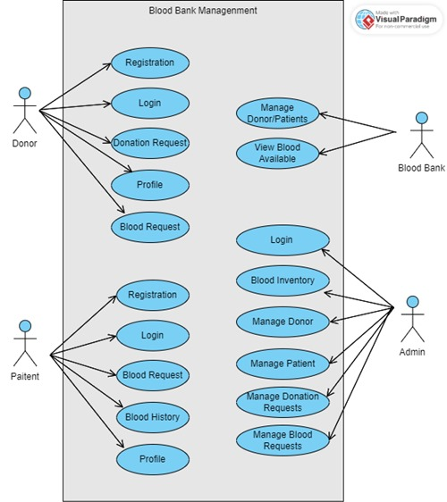

# Results

* Home Page

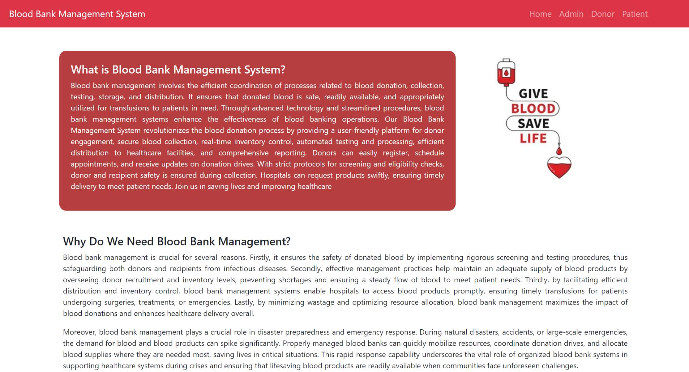

* Admin Module

* Admin login Page

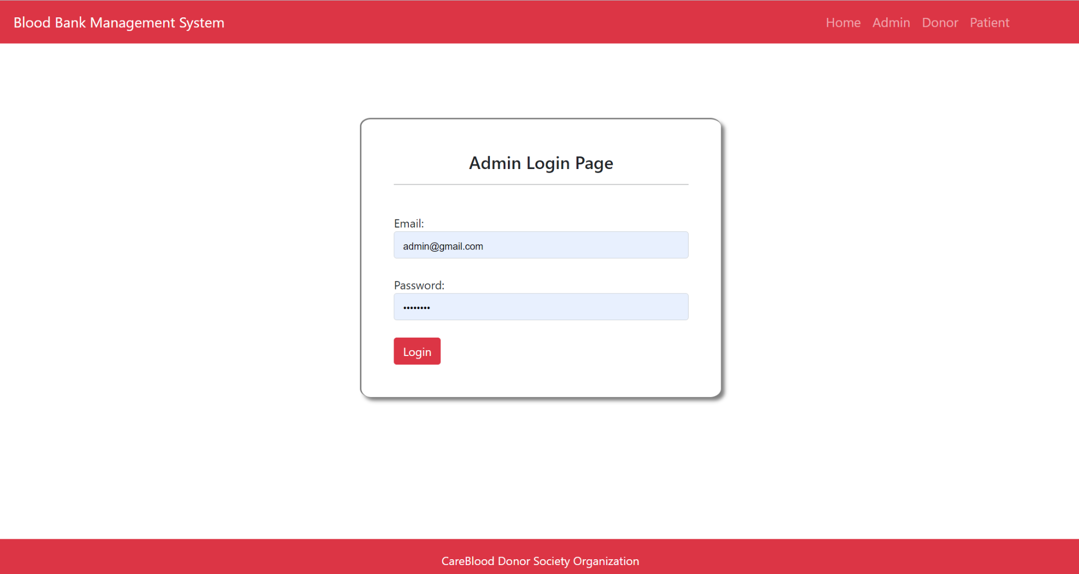

* Admin Dashboard Page

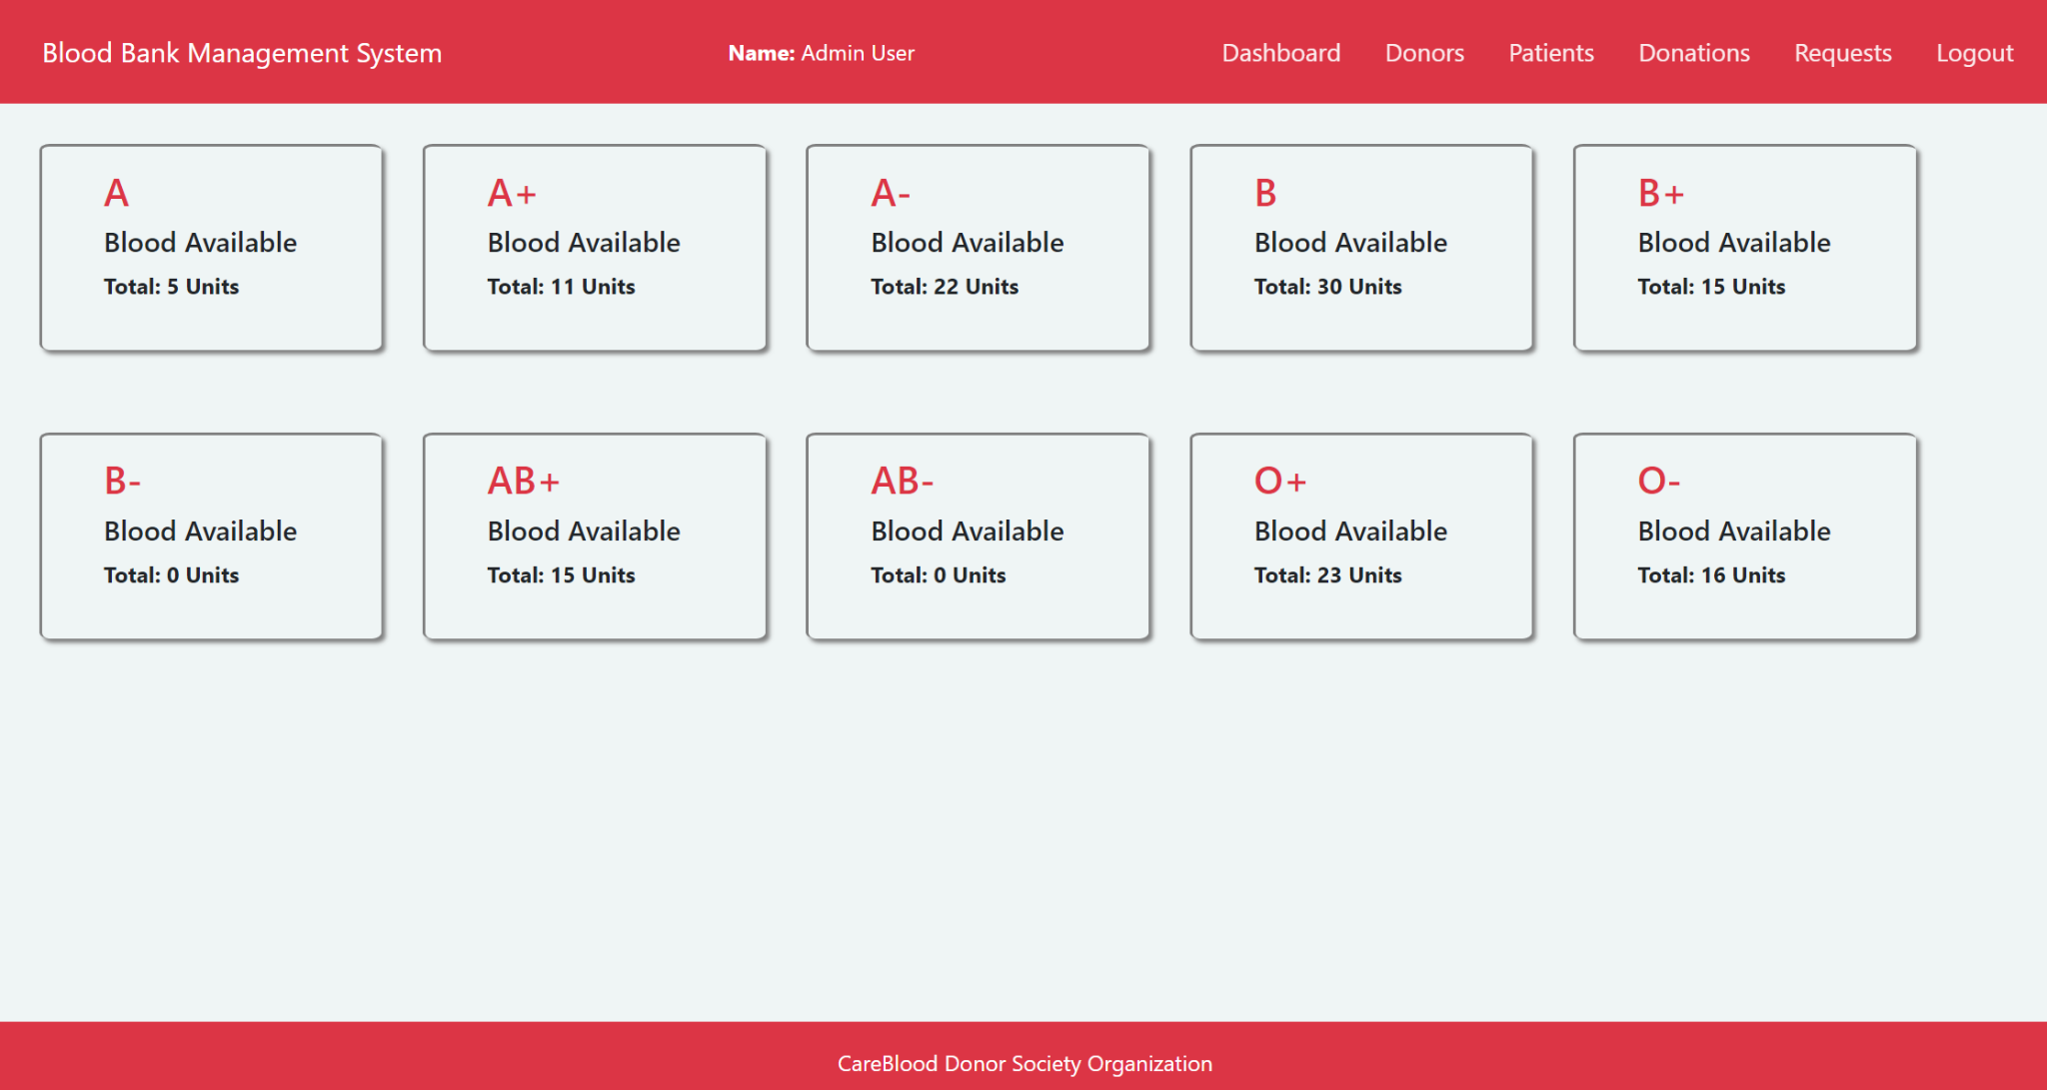

* Manage Donor’s Information

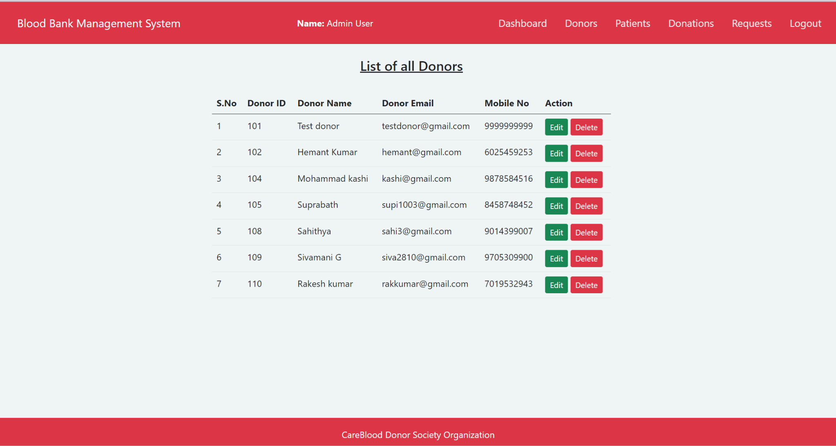

Similarly for patients also admin can edit the information of donor and patient.This function allows admin to update details or delete the user/donors.The updated details will automatically reflect in the Database.

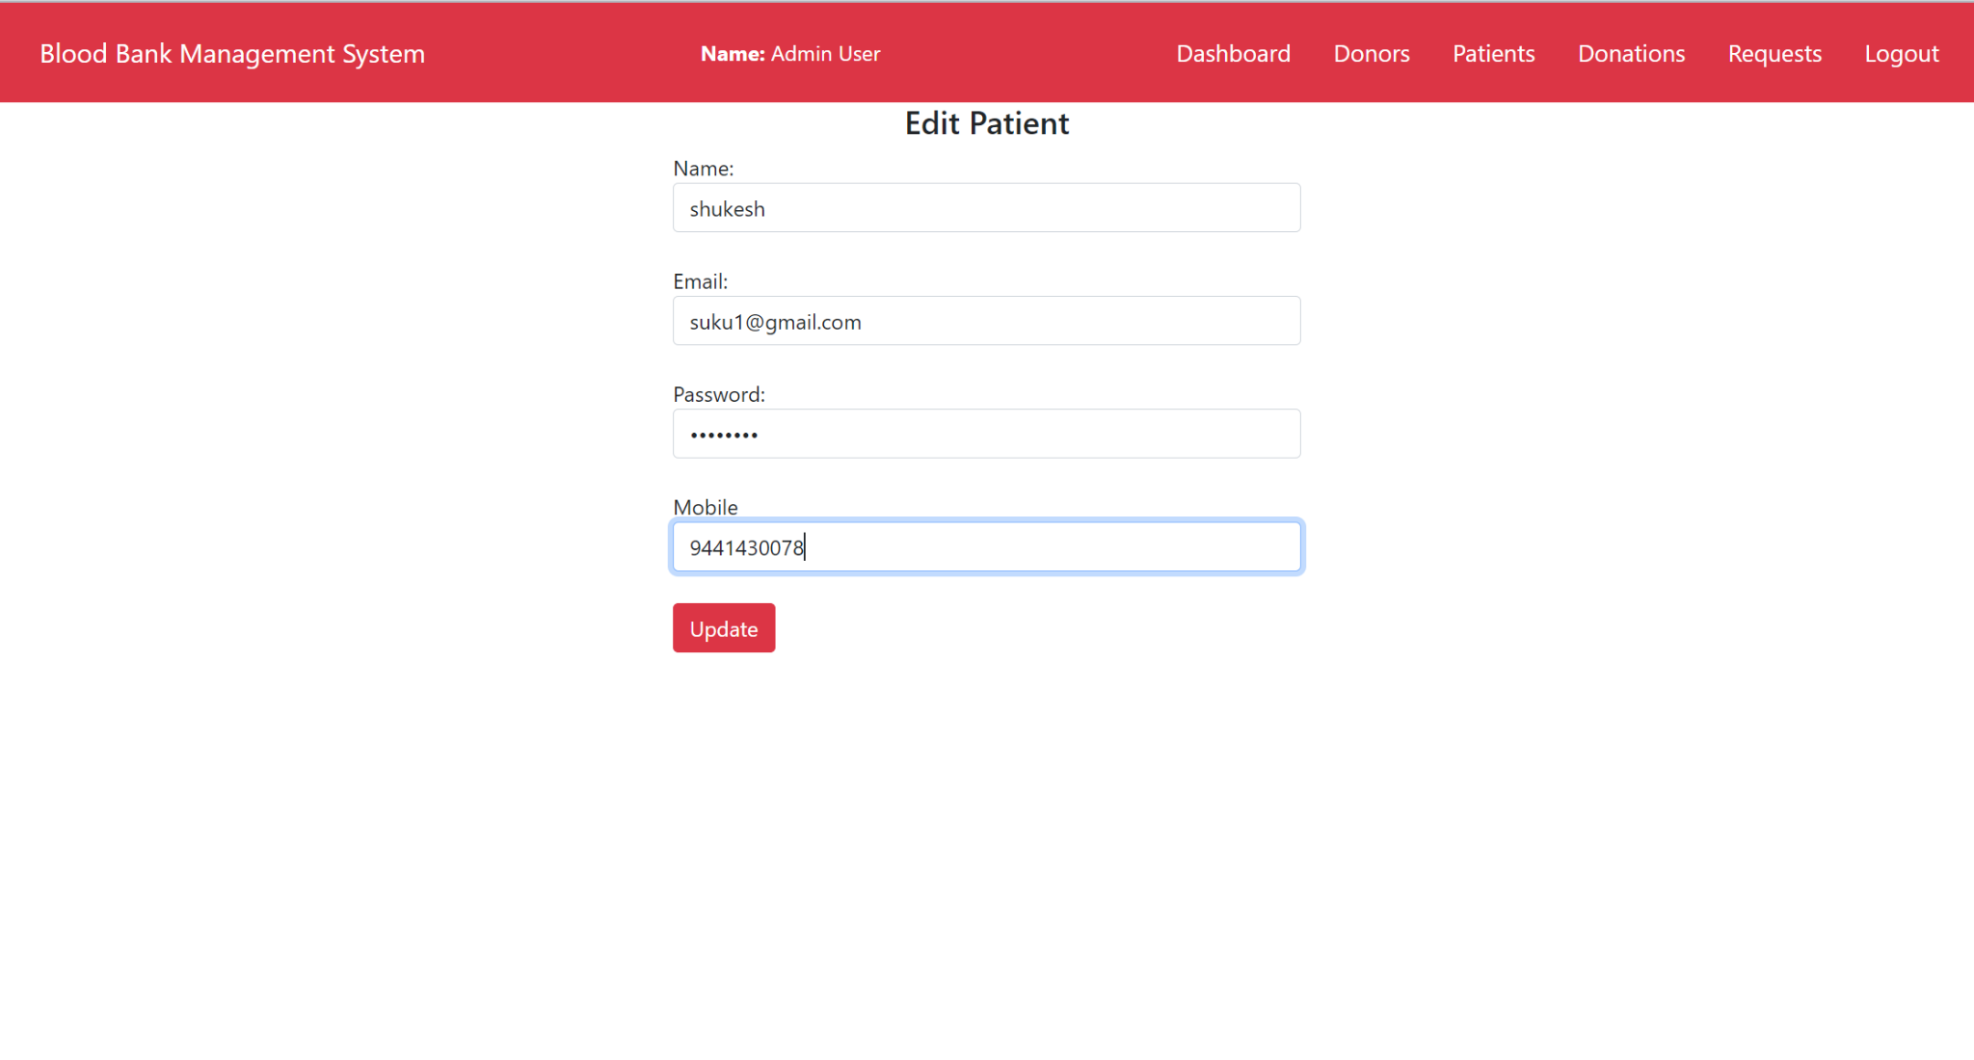

Here the database of Patient:

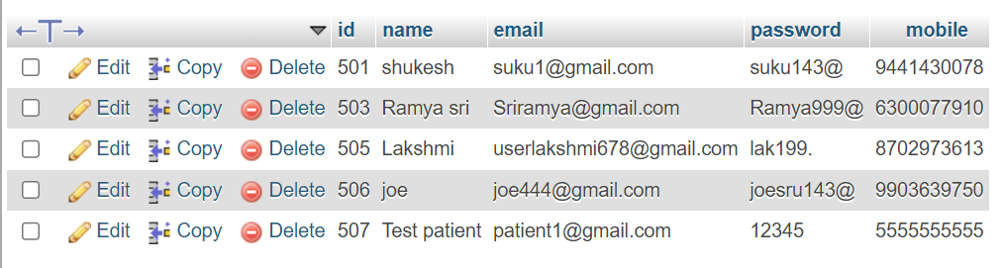

* Manage Donation Request Page

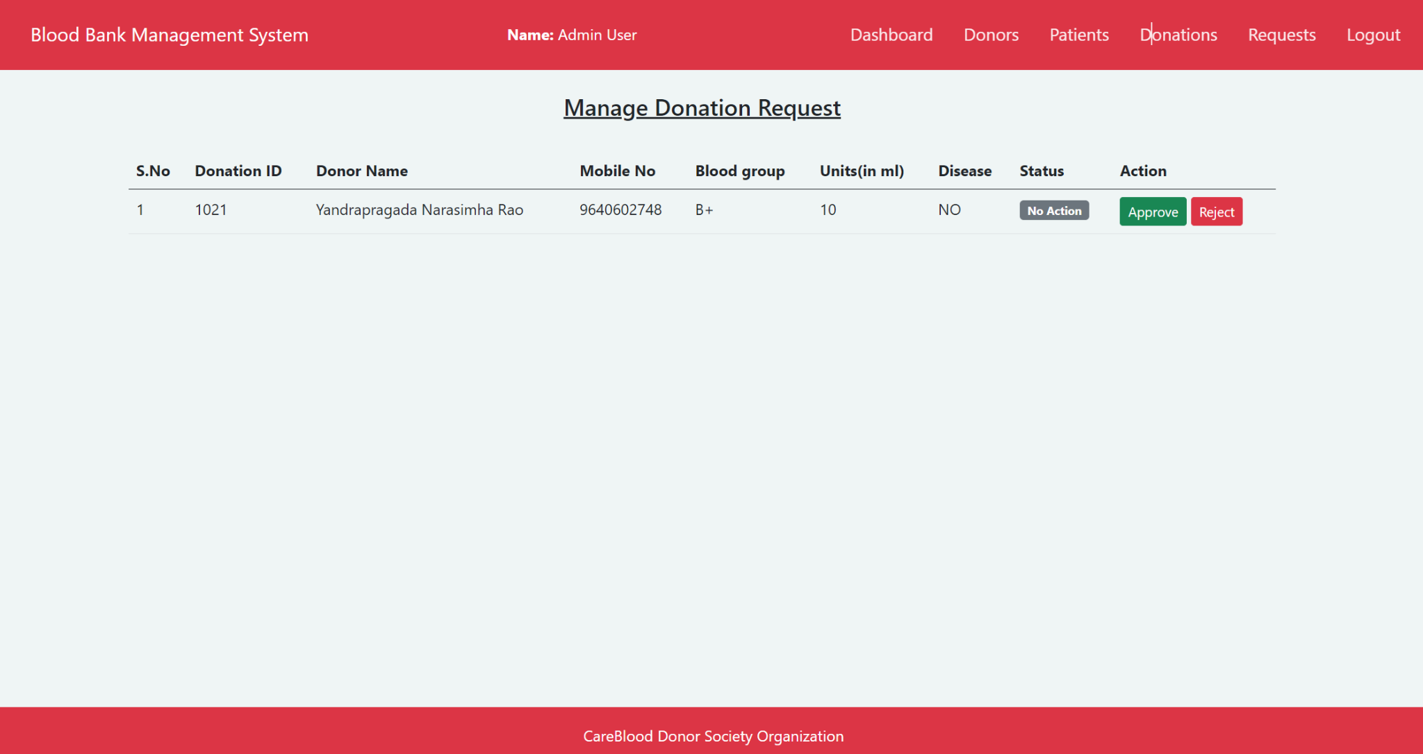

The admin will Approve or Reject the Donation based on diseases,need of the blood group.

* Manage Blood Request Page

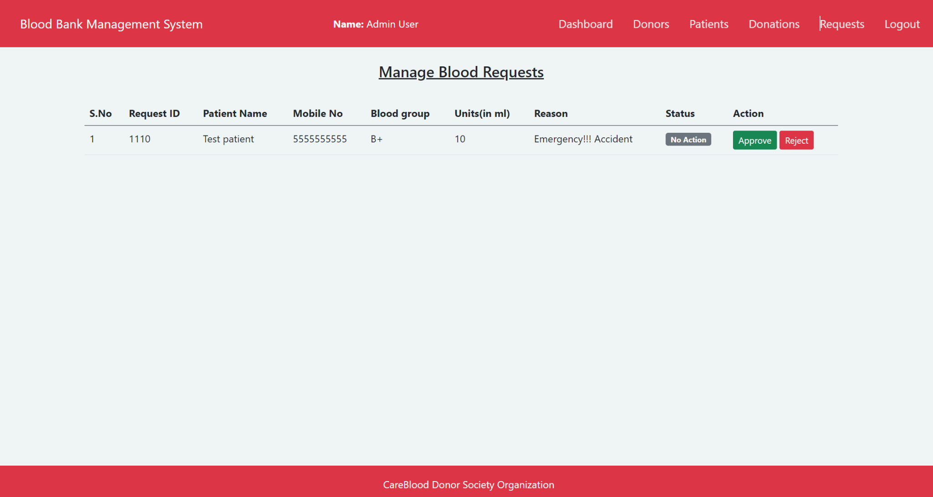

The Admin will Approve or Reject the Request based on availability of blood group and blood units.

* Donor Module
* Donor Login Page

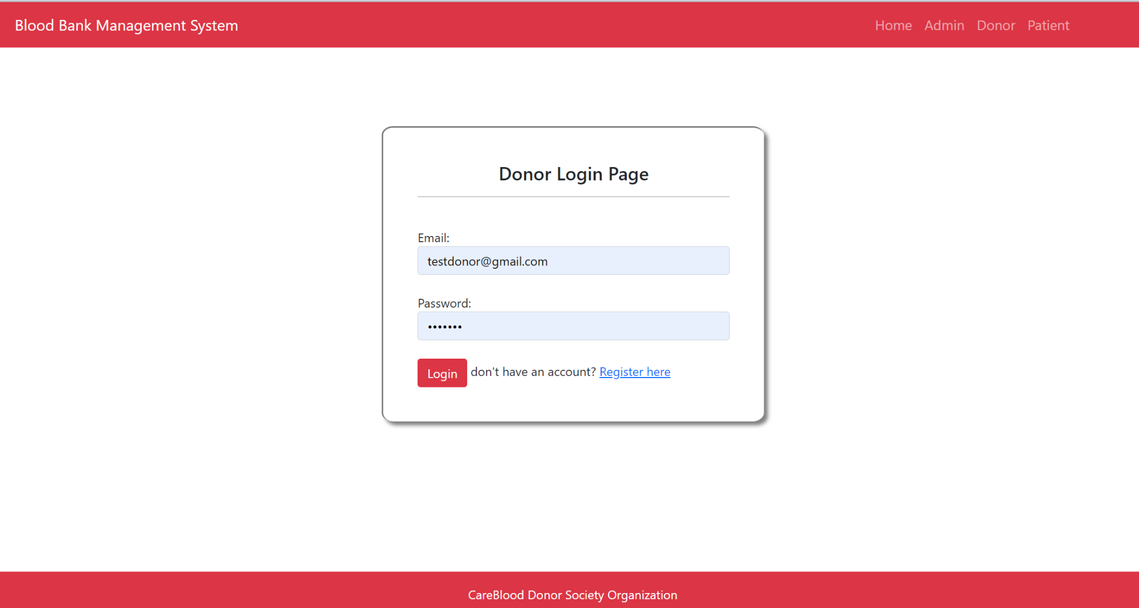

* Donor Registration Page

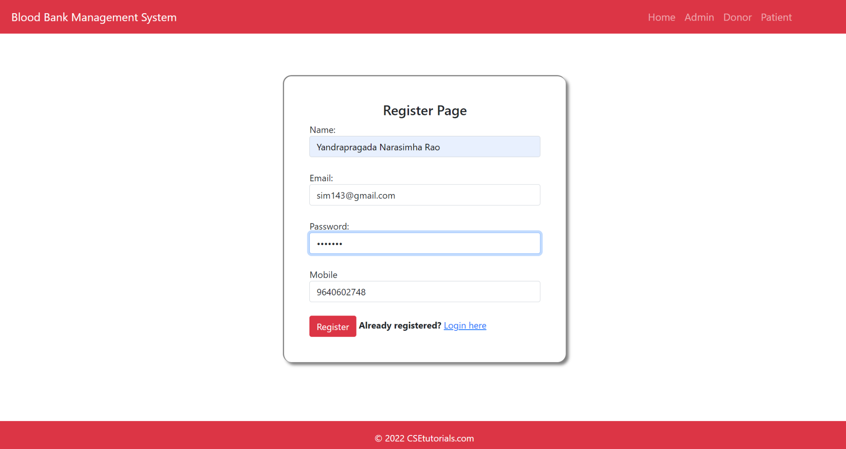

Donor Database

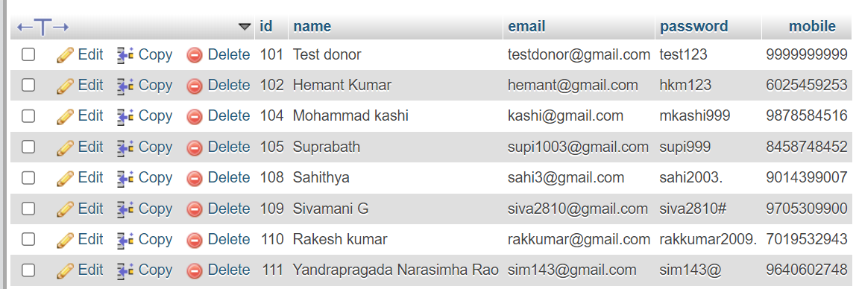

After Registration the details are added into the donor database.

* Donation Page

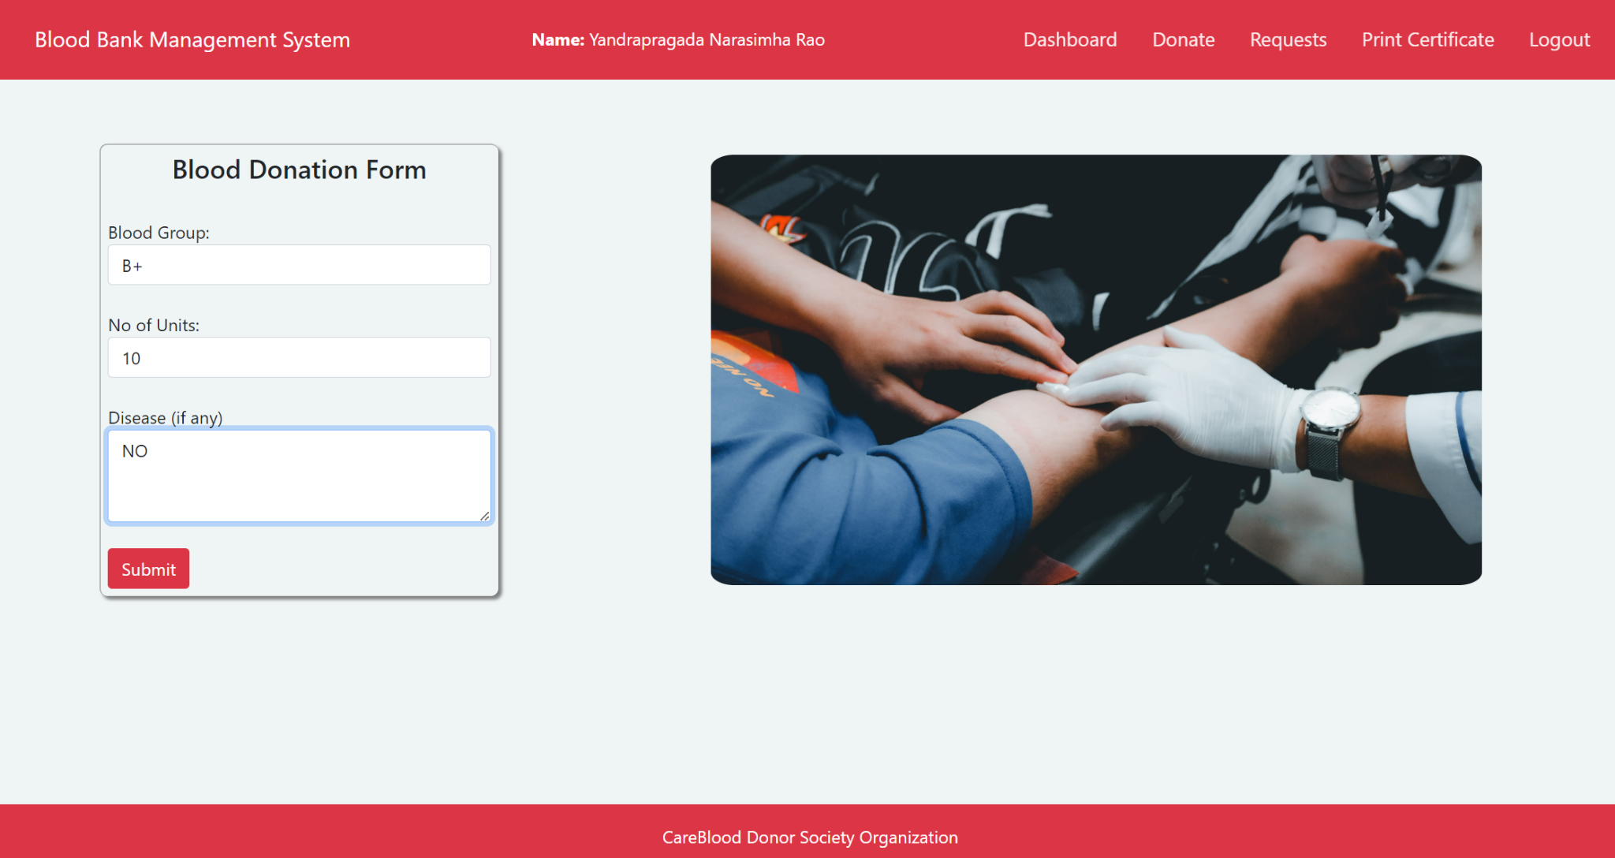

* Donation History Page

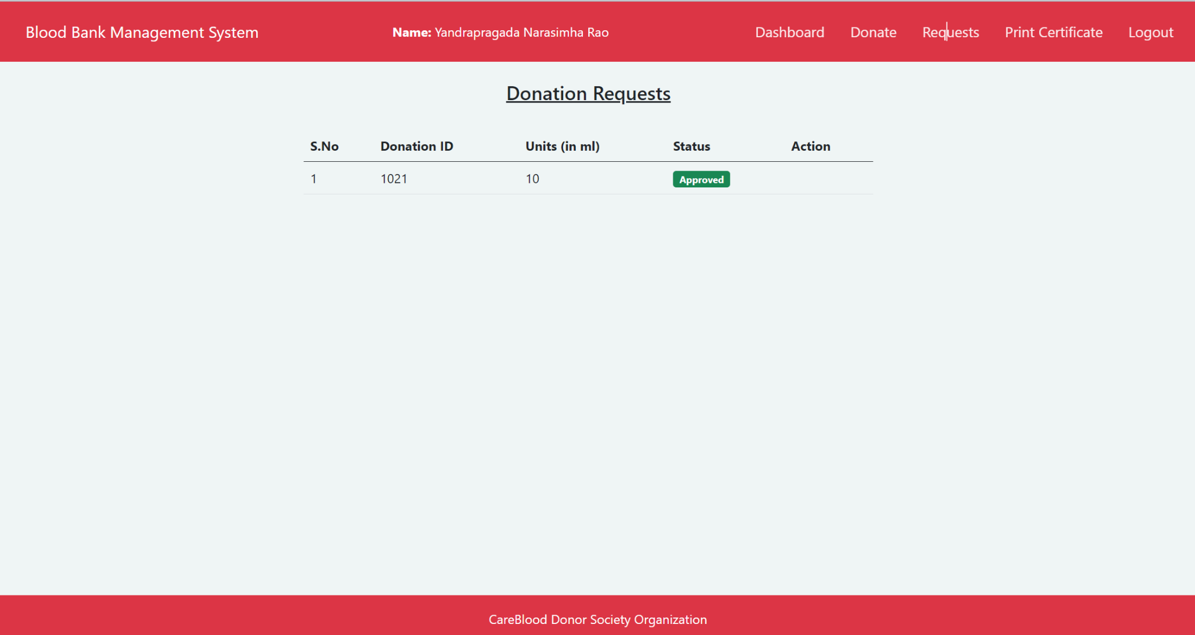

* Print Certificate Page



For all Donors will get a Blood Donation Certificate for their help

* Patient Module
* Patient Login Page

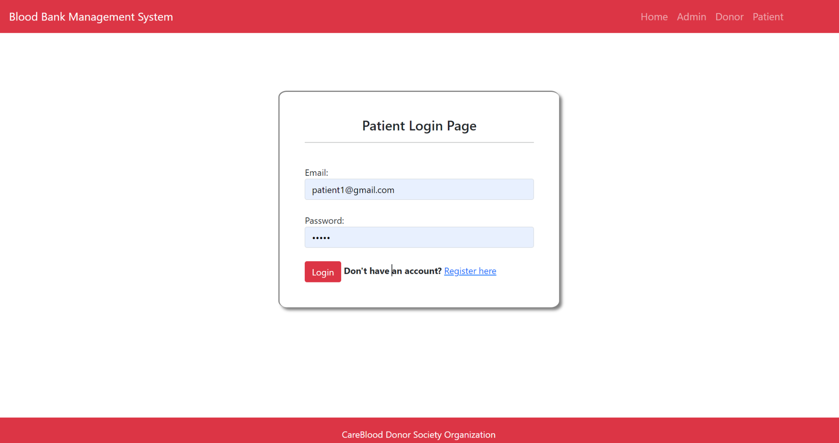

* Patient Register page

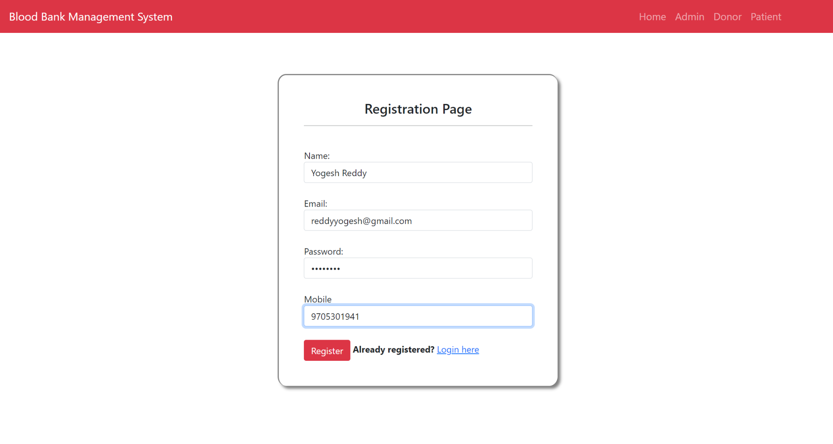

Patient Database

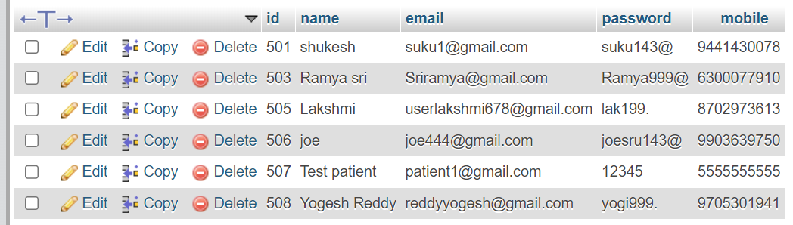

* Patient Dashboard

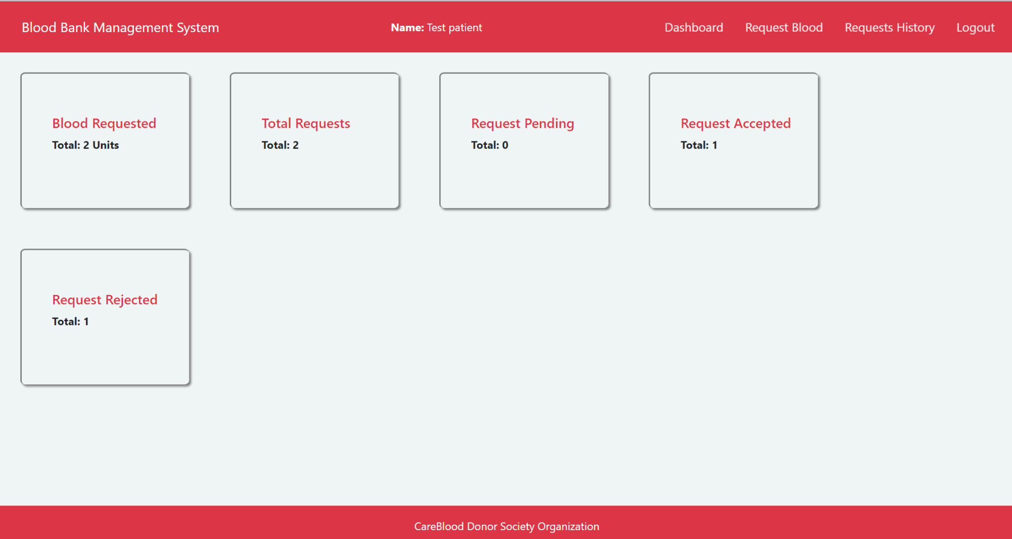

* Blood Request page

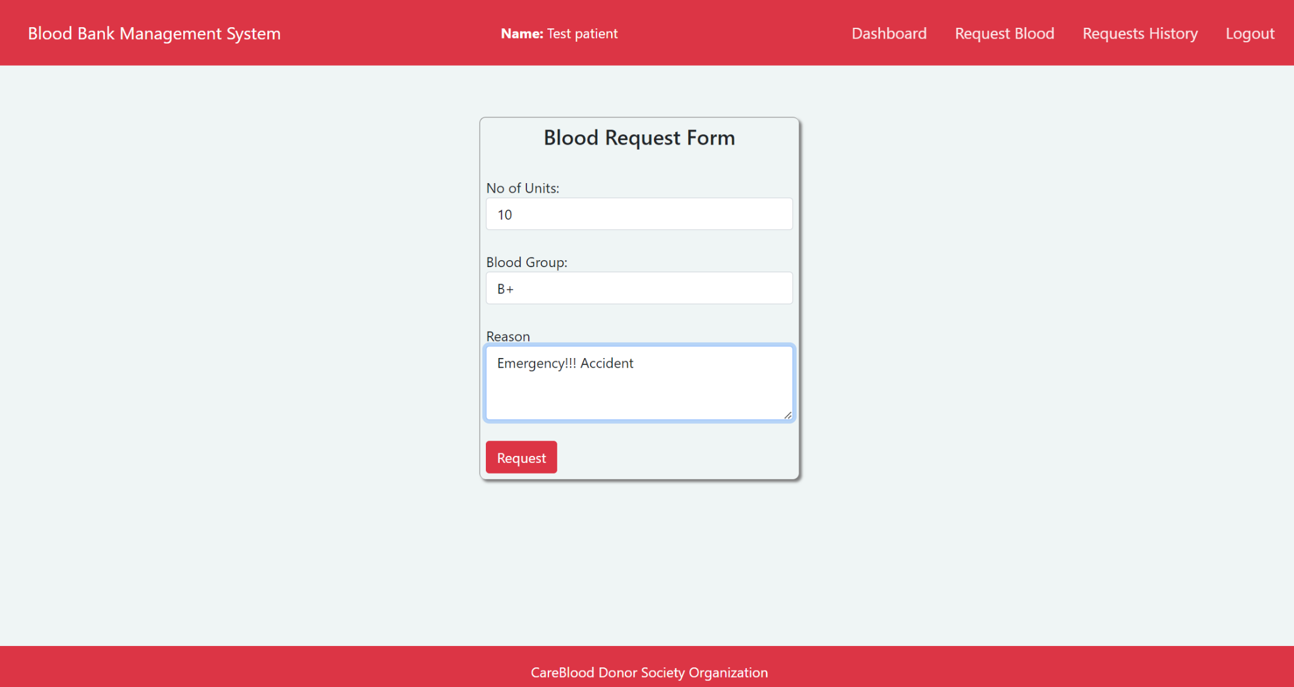

* Blood Request History

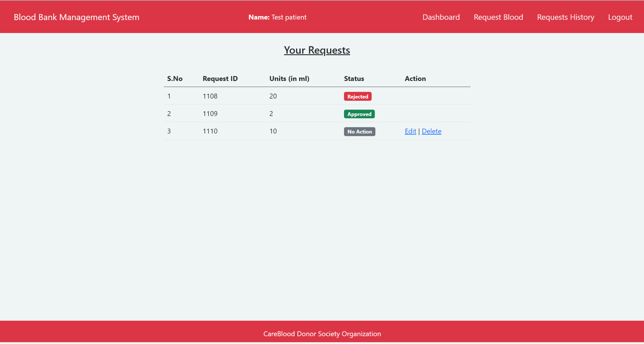

Admin will approve or reject the request based on availability of blood stock.

# Conclusion

The blood bank management system serves as a central platform to streamline the operations of a blood bank, promoting efficient management of blood units, ensuring donor and patient safety, and enabling effective collaboration among stakeholders. It contributes to the overall mission of providing safe and timely access to blood transfusions for those in need. It plays a vital role in the efficient and effective management of blood units, donors, patients, and the overall operations of a blood bank or blood donation center.

By automating and streamlining processes, the system helps ensure a steady supply of safe and high-quality blood units for transfusions and medical procedures. It facilitates donor registration, eligibility tracking, and scheduling, as well as the tracking of blood inventory, testing, and distribution. Ultimately, the blood bank management system serves the crucial purpose of saving lives by ensuring the availability, safety, and accessibility of blood units, contributing to the overall mission of providing quality healthcare to patients in need.

# References

1.<https://www.studocu.com/in/document/delhi-technological-university/database-management-systems/dbms-blood-bank-management-system/26578691>

2.<https://www.slideshare.net/RajendraPrasad361/blood-bank-management-system-94381134>

3.<https://www.academia.edu/30539620/Blood_Bank_Management_System_A_Project_Presentation_on_Internal_Guide>

4.<https://dokumen.tips/engineering/blood-bank-management-system-including-uml-diagrams-58f9d97ee5641.html?page=9>